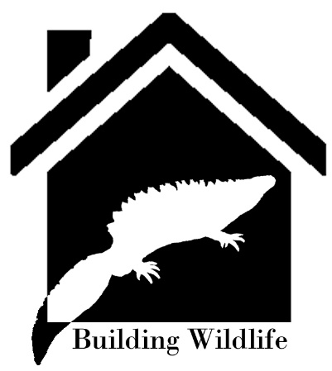 | BUILDING WILDLIFE  NATURE CONSERVATION ACTION  APPLICATION FORM

1.

Applicants Name:

2.

Address:

Postcode:

Telephone No:

Fax No:
E-Mail Address:

3.

Applicant Status:
(i.e. owner, agent, etc)

4.

Name and Address Of

Owner If Different

From Above:
Signature of Owner |  | Date

5.

Name and Address Of

Occupier If Different

From Above:
Signature of Occupier |  | Date

6.

Grid Ref of Site:
(6 figures)

7.

Provide a very brief description of the project and what it aims to achieve:

8.

Describe the existing habitats and site conditions within the proposed location site for the project:

9.

Have any alternative locations for the work been considered? If yes, please provide details:

10.

Provide a Map of the Site and proposed work including access routes:

11.
Is this project subject to any other funding? Have any other grants been issued for this project by any other organisation? If yes, please provide details:

12.
What are the main target species and/or habitats?

13.
Are there any statutory or non-statutory designations on the land: ((e.g. Area of Outstanding Natural Beauty (AONB), Site of Special Scientific Interest (SSSI), Local Wildlife Site, Scheduled Ancient Monument etc))
Will you require any necessary consents to implement the project?  If yes, provide details | Yes | No

14.
Have any European Protected Species (EPS) development or conservation licences been granted by Natural Resources Wales (NRW)? If so, provide licence reference number and attach an electronic copy.

15.
Are any non-native species present? | Yes | No
If yes, have NRW/North Wales Environmental Information Service (Cofnod) been informed?

16.
Project Description:

Explain how the project benefits the target species, habitat or has wider benefits to the public involving quiet recreational enjoyment

What other species have been taken into consideration? Are there predicted to be any negative effects? If so, provide mitigation measures for this e.g. pond re-lining/fish eradication needs to consider disturbance and loss of aquatic plants, potential effects on species such as amphibians, water shrew, water vole or effects on habitats.

Are there any other species or habitats of national and/or local importance that have been identified which might be disturbed or affected by the project?

Are there any historical or archaeological interests which may need to be taken into consideration?

Attach method statement, and project management/ ecological oversight details/biosecurity measures

Proposed dates of commencement and completion

17.
Provide a breakdown of costs and if exceeding £5,000, then please provide three competitive quotes from suitable, reputable and competent contractors:

18.

Total amount of funding requested.

Specify the stages of project at which payment of funds will be made e.g. total £10000 to be paid in 4 stages. Stage 1 - £4000. Stages 2, 3 & 4 - £2000 at each stage.

19.

How will project be maintained and funded in the future?

20.

What monitoring of the species and habitats will be carried out and by whom for what period of time? Please specify if this is a requirement of an NRW species conservation licence

21.

What are the access arrangements for site visits by BWT Trustees before, during and after the approval of funds and any project works undertaken? Please provide contact details including names of contacts, their roles, telephone numbers and email addresses

Signature of Applicant:

Date:

Return form together with 1:2500 plan to info@buildingwildlife.org.uk

No work should commence until you have received a formal written approval.

Conditions

On Completion of work prior to issue of grant funds, the following information will be required in the form of a report–

- Photographic and descriptive record of work carried out including the dates;
- Site personnel, ecologist present and overseeing work;
- Survey data collected and species recorded at the site during the project (also to be submitted to Cofnod);
- Records of any tool box talks carried out if applicable and a summary of information provided to NRW/Local Planning Authority/Cofnod.

TERMS AND CONDITIONS

1. A written offer of a grant which specifies the amount of grant which you will receive upon satisfactory completion of the work must be obtained from Building wildlife(BW) before work commences unless otherwise agreed.

2. The offer of the grant does not exclude the need for relevant consents/licences. All necessary consents/ licences – for example in respect of designated sites and protected species – need to be obtained prior to the work commencing.

3. Payment will only be made after the scheme has been completed to the satisfaction of BW and receipts for approved expenses incurred and or submission of evidence eg photographs to confirm implementation.

4. Work to be completed and claims made within one calendar year of date of Grant Offer”.

5. If the applicant wilfully destroys or damages a feature which has been subject of grant aid within 10 years of the scheme’s date of completion, then BW reserve the right to reclaim the grant in part or in full. Monitoring site visits may follow completion of the scheme subject to access agreement if required.

6. Grant aid will not be offered for works required to satisfy a condition of planning consent or species mitigation as part of EPS licencing under permitted development or planning consent.

7. All work carried out under the scheme must be carried out in accordance with the relevant British Standards or Best Practice whilst complying with legislation.

8. BW trustees and anyone appointed by BW must be permitted access to the site for the purposes of project assessment and review before, during and after the project for a period of 10 years.

9. Any changes to proposed time scale and proposed project must be agreed by BW prior to implementation.

10. BW requires prior notification of commencement of works with at least
7 days notice.

